**CLOUDANT DB**

**TEAM ID : PNT2022TMID26050**

**PROJECT NAME: PERSONAL ASSISTANCE FOR SENIORS WHO ARE SELF RELIANT**

1. Open cloudant db and launch dashboard

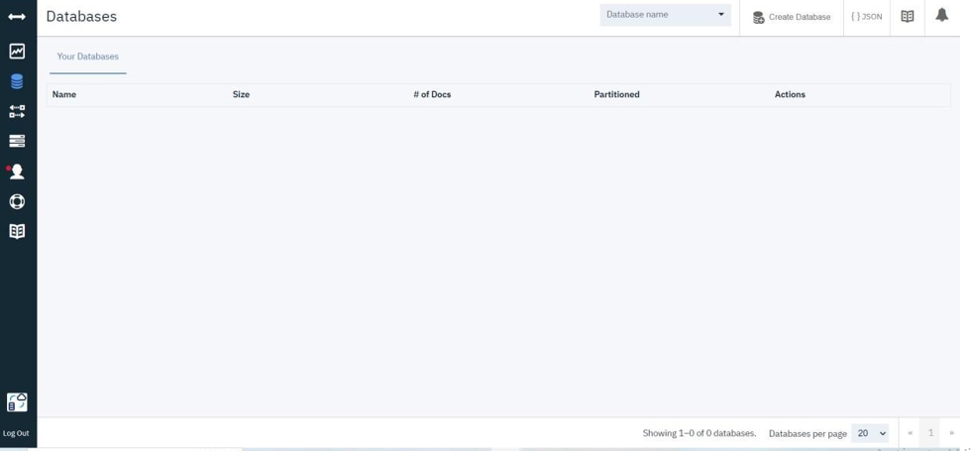

1. Create the database

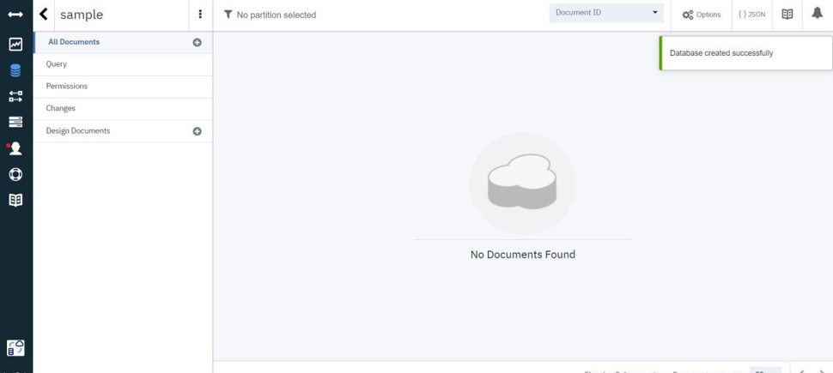

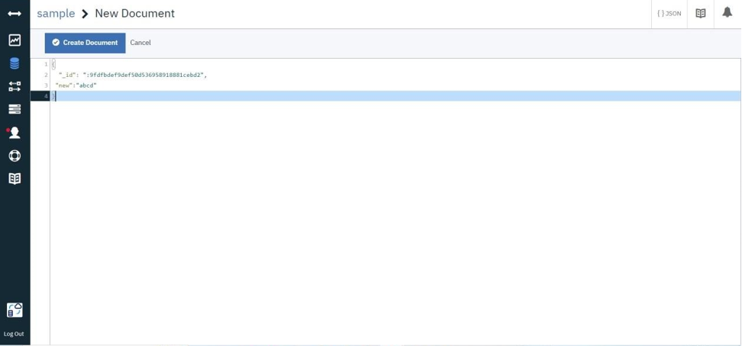

1. **Create the document and save it**

